PIZZA SALES SQL QUERIES
- Total Revenue
SELECT SUM(total_price) AS total_revenue FROM pizza_sql;
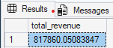

- Average Order Value
SELECT SUM(total_price)/COUNT(DISTINCT order_id)
AS Avg_Order_Value
FROM pizza_sql;
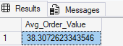

- Total Quantity Sold
SELECT SUM(quantity)
AS Total_quantity
FROM pizza_sql;


- Total Order Placed
SELECT COUNT(DISTINCT order_id)
AS Total_Order
FROM pizza_sql;


- AVERAGE PIZZA SOLD PER ORDER
SELECT COUNT(pizza_id)/COUNT(DISTINCT order_id)
AS Avg_pizza_per_order
FROM pizza_sql;
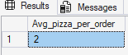

- TOTAL NUMBER OF ORDERS BASED ON DAILY TREND(WEEKLY)
SELECT DATENAME(DW,order_date) AS Order_day,
COUNT(DISTINCT order_id) AS Total_order
FROM pizza_sql
GROUP BY DATENAME(DW,order_date);
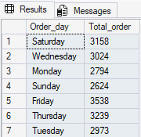

- TOTAL NUMBER OF ORDERS BASED ON MONTH
SELECT DATENAME(MONTH,order_date) AS Order_Month,
COUNT(DISTINCT order_id) AS Total_order
FROM pizza_sql
GROUP BY DATENAME(MONTH,order_date);
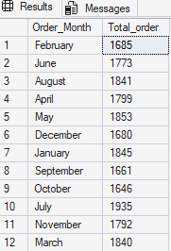

- PERCENTAGE OF PIZZA SALES PER CATEGORY
SELECT pizza_category,SUM(total_price) AS Total_Revenue,
SUM(total_price)*100/(SELECT SUM(total_price) FROM pizza_sql)
AS Percent_price
FROM pizza_sql
GROUP BY pizza_category;
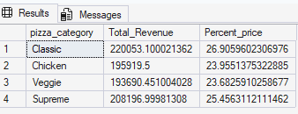

- PERCENTAGE OF PIZZA SALES PER CATEGORY FOR FEBURARY MONTH
SELECT pizza_category,SUM(total_price) AS Total_Revenue,
SUM(total_price)*100/(SELECT SUM(total_price) FROM pizza_sql WHERE MONTH(order_date) = 2) AS Percent_price
FROM pizza_sql
WHERE MONTH(order_date) = 2
GROUP BY pizza_category;
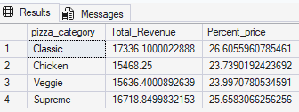

--NOTE: WHENEVER WE HAVE TO FIND THE DATA FOR ANY PARTICULAR MONTH WE WILL USE WHERE IN THE QUERY LIKE IN ABOVE I HAVE USED THE SYNTAX AS WHERE MONTH(order_date) = 2 i.e. FEBURARY.
PERCENTAGE OF TOTAL REVENUE OF PIZZA AS PER ITS SIZE
SELECT pizza_size,SUM(total_price) AS Total_Revenue,
SUM(total_price)*100/(SELECT SUM(total_price) FROM pizza_sql)
AS Percent_price
FROM pizza_sql
GROUP BY pizza_size
ORDER BY Percent_price DESC;
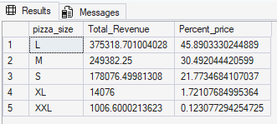

- TOP 5 BEST SELLLING PIZZA AS PER ITS PRICE WITH ITS TOTAL ORDER COUNT
SELECT TOP 5 pizza_name, SUM(total_price) AS Total_Revenue,
FROM pizza_sql
GROUP BY pizza_name
ORDER BY Total_Revenue DESC;
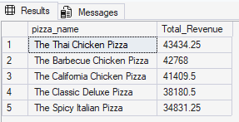

- BOTTOM 5 SELLING PIZZA ALONG WITH TOTAL REVENUE
SELECT TOP 5 pizza_name, SUM(total_price) AS Total_Revenue
FROM pizza_sql
GROUP BY pizza_name
ORDER BY Total_Revenue ASC;
